Psalm 138 Common Worship Chant: Antony Green

Chant on a single line of music:



Or, on two lines of music for copying into narrow columns:

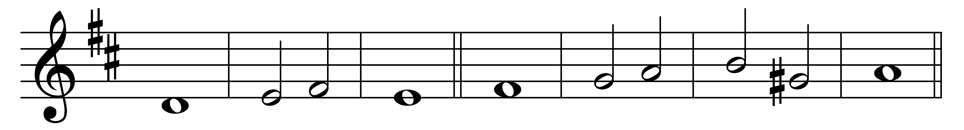

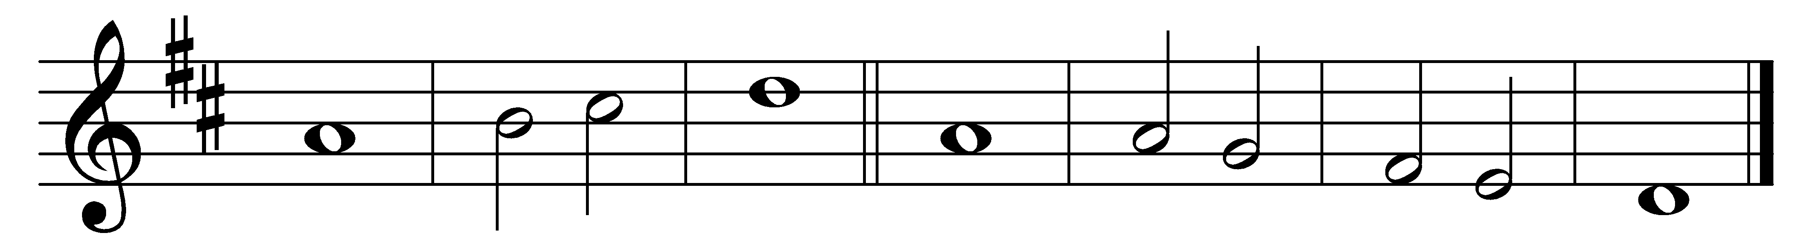

I will give thanks to you, O Lord, with my | whole | heart;

before the gods will I | sing | praise to | you.

2 I will bow down towards your holy temple and praise your name, because of your | love and | faithfulness;

for you have glorified your name and your | word a-| bove all | things.

3 In the day that I called to you, you | answered | me;

you | put new | strength· in my | soul.

4 All the kings of the earth shall | praise you,· O | Lord,

for they have | heard the | words· of your | mouth.

5 They shall sing of the | ways· of the | Lord,

that | great· is the | glory· of the | Lord.

6 Though the Lord be high, he watches | over· the | lowly;

as for the proud, he re-| gards them | from a-| far.

7 Though I walk in the midst of trouble, | you· will pre-| serve me;

you will stretch forth your hand against the fury of my enemies; your | right hand· will | save | me.

8 The Lord shall make good his | purpose· for | me;

your loving-kindness, O Lord, endures for ever; for-| sake· not the | work· of your | hands.

Words taken from Common Worship © The Archbishops’ Council 2000.